Safety report

Nuclear power station

Contents

How does a nuclear power station: 3

Health hazards for nuclear plants: 3

IAEA (international atomic energy agency): 4

Risk matrix: 4

Safety Precautions 6

Location: 6

Construction: 6

Precautions in the nuclear reactor: 6

Containing radiation 6

Control reactivity 7

Cooling the fuel 8

Operational safety: 9

Real life case study for the safety at a nuclear power plant: 9

Chernobyl: 9

Fukushima: 10

Three Mile Island 10

When we talk about risky industries the first things that comes to our minds is construction or steel manufacturing; however, incidents in such industries rather cause an individual harm. An industry that we tend over looked, yet when accidents does happen it acts as a menace to all human beings, is nuclear industries, particularly nuclear power stations.

Using nuclear power plants is beneficial in large scale industries as they meet the needs of the industrialized countries with a reasonable electricity distribution grid. Not only do they produce endless clean energy, but also they are long lasting.

# How does a nuclear power station:

Works largely like a conventional thermal power planet where water is converted into steam, driving turbine connected to a generator, thus converting mechanical energy into electrical energy. The only difference is that the heat is produced by nuclear fission.

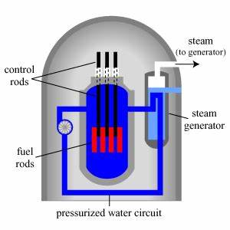Fuel used is uranium oxide. It is compressed into fuel pellets and packed into sealed fuel rods. Multiple rods in turn form the fuel elements which are immersed in water in a reactor vessel.

Fission of the uranium can now begin by bombarding it with neutrons. In each fission 2 or 3 neutrons are released, thus causing new fissions creating a chain reaction; however, only One released neutron should cause a new fission

For that reason, It is significant that this reaction is controlled using Control rods and boric acid to absorb the oversupply of neutrons.

# Health hazards for nuclear plants:

Research shows that those who received the highest doses, may have a increased risk of developing solid cancers and cardiovascular disease. Exposure to very high levels of radiation, can also cause acute health effects such as skin burns . Those who look directly at the blast could experience eye damage ranging from temporary blindness to severe burns on the retina. A Long-term effect for being exposed directly to radiation is genetic damage. These radiation can either kill cells or damage the DNA within them, which damages their ability to reproduce and can eventually lead to cancer.

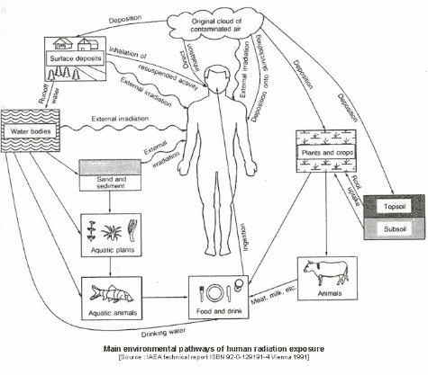

# IAEA (international atomic energy agency):

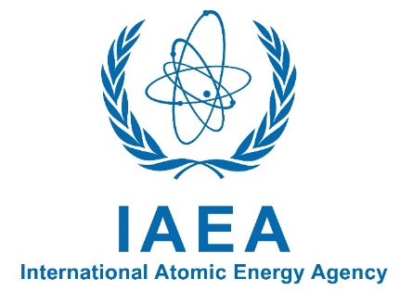the IAEA is a Safety Standards Series, which all nuclear plants follow to ensure the safe being of all plants, workers and the environment. This series covers nuclear safety, radiation safety, transport safety and waste safety. These rules do not only apply to nuclear energy production, but also all nuclear application such as medical. the IAEA safety standards establish fundamental safety principles, requirements and measures to control the radiation exposure of people and the release of radioactive material to the environment, through risk assessment. They also restrict the likelihood of events that might lead to a loss of control over a nuclear reactor core, nuclear chain reaction, radioactive source or any other source of radiation and to mitigate the consequences of such events if they were to occur.

# Risk matrix:

A risk matrix is a matrix that is used during risk assessment to define the level of risk by considering the category of probability or likelihood against the category of consequence severity. This is a simple mechanism to increase visibility of risks and assist management decision making. An example for an risk matrix for a nuclear power plant:

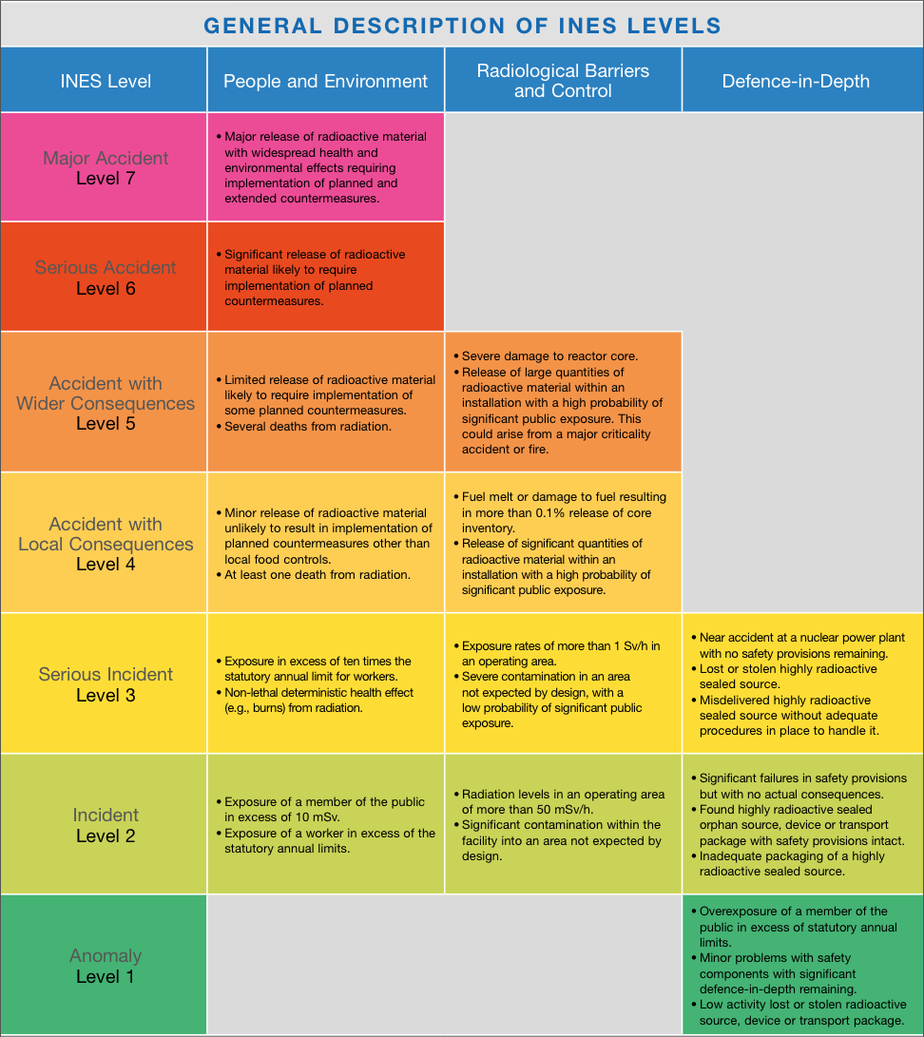

# Safety Precautions

the design and operation of nuclear power plants aims to minimize the likelihood of accidents, and avoid major human consequences when they occur.

### Location:

* To safely handle the enormous amounts of heat produced by nuclear fission, these power plants rely on a cooling system. As water is a great way to cool down a reactor, many plants are located along rivers and coasts where water is plentiful and free. therefore, suitably located either at coastal sites or at inland sites by the side of a reservoir or a river.
* Building in an area that rarely earthquakes happen in it is important as earthquakes causes damage in the power plants than causes explosions that lead to severe damages, as well as other possible natural disasters
* As far asway from civilizations as possible to avoid harming the citizens

### Construction:

* Buildings are designed to not be too tall in order to avoid being brought down by storms and not too low in order not to be flooded by tides and floods
* A containment building is a reinforced steel, concrete or lead structure enclosing a nuclear reactor. It is designed, in any emergency, to contain the escape of radioactive steam or gas.

# Precautions in the nuclear reactor:

### Containing radiation

Containing the radiations from the reactors are done in 4 layers and the aim of these layers is to minimize the release of radiations from the nuclear power plants into the atmosphere.

1st layer: the radiation is stored in a hardened ceramic pellet made of natural uranium.

2nd layer: the pellets that contain the radiation are contained in rods made of a metal called zircaloy that is extremely resistant to heat and corrosion.

3rd layer: a pressure tube that is inside a metal tank called calandria

4th layer: final layer is a thick vault made of concrete

### Control reactivity

Sensitive detectors are present in a reactor to control and monitor temperature, pressure, and the reactor power level. As if error or mistakes occurred the reactors shutdown automatically without the need of power and it can also be controlled manually. After the shutdown of the reactor there is no risk and no possibility of the reactor to work again on its own until it is turned back on manually. A huge amount of energy is reduced rapidly during the reactor shutdown; however, the reactor still produces some heat that is called decay heat that still need to be cooled.

### Cooling the fuel

Due to the exerted decay heat and continuous cooling process happens from the cooling system, and there are two main systems.

1. Heat transport system: the heat produced by the reactor is absorbed by steam generators. Steam generators are made up of pipes filled with heavy water which is a rare type of water found in nature and this helps in the cooling process.
2. Steam system: using normal water, the heat produced from the reactor changes the water present into steam to run the turbines that cools and condense the steam that helps in reducing the heat.

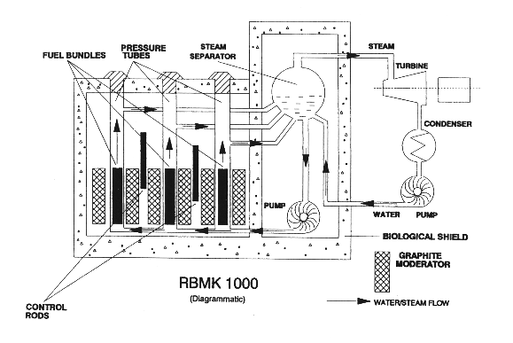

# Operational safety:

Employees must go through adequate training facilities, including a representative simulator, appropriate training materials in advance. Strict adherence to written operating procedures shall be an essential element of safety policy at the plant. PPE (personal protective equipment) is essential as it protects against the various hazards present in nuclear power plants. Such gear are required to be left at the work place in order to prevent the spread of take-home toxins

# Real life case study for the safety at a nuclear power plant:

### Chernobyl:

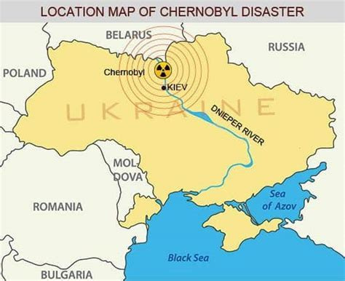 In north Ukraine, in April 1986, the worst nuclear accident in the history of [nuclear power](https://www.britannica.com/science/nuclear-energy) generation took place. The Chernobyl factory contained four reactors. Some technicians were preparing to test the cooling tower of the 4th reactor, something went wrong. While a large number of controls rods that is made of zircaloy were removed to be tested, the pellets containing the radiations were left on its own, causing a flow of temperature and heat release that they lost control on. This led to extreme heat that made the cooling pump core totally meltdown totally causing the reactors to explode. 8 tons of radioactive radiations was released in the atmosphere which were subsequently found in fresh water, fish, wood, fresh food, meat and milk products. Not to mention, the 31 people who were trying to set off the fire that died after weeks due to being directly exposed to these toxic radiations. Now, this 4th reactor has been rebuilt, yet surrounded and layered by concrete that is 110m high and its width is larger than the titanic ship.

### Fukushima:

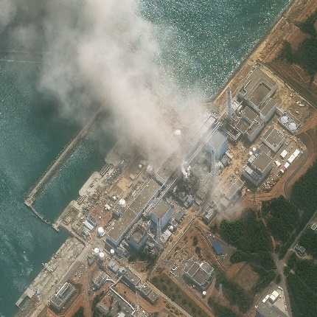In 2011 at the Number One [plant](https://www.britannica.com/technology/nuclear-power-plant) in northern [Japan](https://www.britannica.com/place/Japan), another great nuclear accident occurred. On march 11th a tsunami hit Fukushima Daiichi causing an [earthquake](https://www.britannica.com/event/Japan-earthquake-and-tsunami-of-2011), which damaged the [power](https://www.britannica.com/dictionary/backup) generators at the plant. Although all three of the reactors that were operating were successfully shut down, the loss of power caused cooling systems to fail in each of them within the first few days of the [disaster](https://www.britannica.com/science/disaster). The Rise in residual [heat](https://www.britannica.com/science/heat) within each reactor’s core caused the fuel rods in reactors 1, 2, and 3 to overheat and partially melt down, leading at times to the release of [radiation](https://www.britannica.com/science/radiation) inside the containment vessel. However, the melted material fell to the bottom of the containment vessels in reactors 1 and 2 and bored sizable holes in the floor of each vessel that partially exposed the nuclear material to the air and the leakage of the Radioactive material into the atmosphere and the Pacific Ocean.

### Three Mile Island

In Pennsylvania on March 28th 1979, A major cooling pump broke down in the cooling tower that caused some radioactivity to escape which caused a partial meltdown in the reactor, the loss of radioactivity and the breakdown of the cooling pump caused the reactor to shut down automatically without causing any nuclear explosion. No injuries or adverse health effects where record. Three mile island is a great example is how the necessary measures taken cause significantly aid in the mitigation of extreme consequence.

